# Required Components

3

|  |  |
| --- | --- |
| A button, two lengths of wire, and a switch jack laid out on a white background  4  2  1 | **BOM**   1. 1X Speaker button 2. 2X 50 mm (2 in) lengths of wire 3. 1X 3.5 mm switch jack   Optional:   1. 1x 3.5mm female mono cable (replaces 2 and 3) 2. 1x Zip Tie (if using 4) |

# Required Tools

* Soldering Iron
* Solder
* Wire cutters
* Wire strippers
* Drill
* ¼ inch drill bit
* Flat head screwdriver
* Small Phillips screwdriver

# Required Personal Protective Equipment (PPE)

* Eye protection

# Assembly Instructions (if using 2 and 3)

## Step 1 – Flip button over

Flip over the button to expose the bottom.

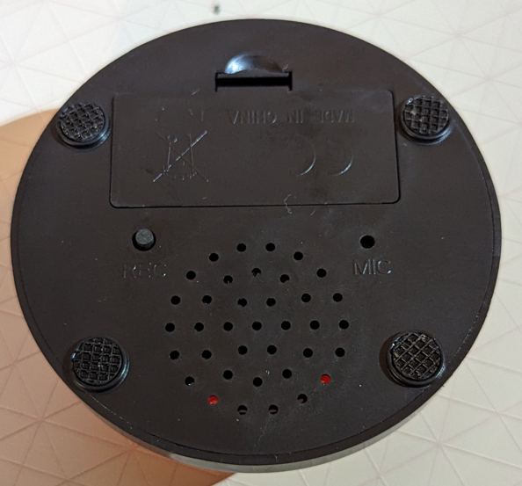

## Step 2 – Remove the batteries

Remove the batteries from the switch to power off the device.

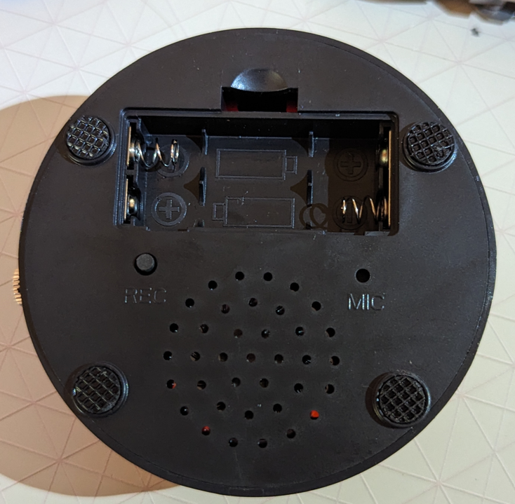

## Step 3 – Remove the feet

Using a flat head screwdriver, pry off the rubber feet and set them aside.

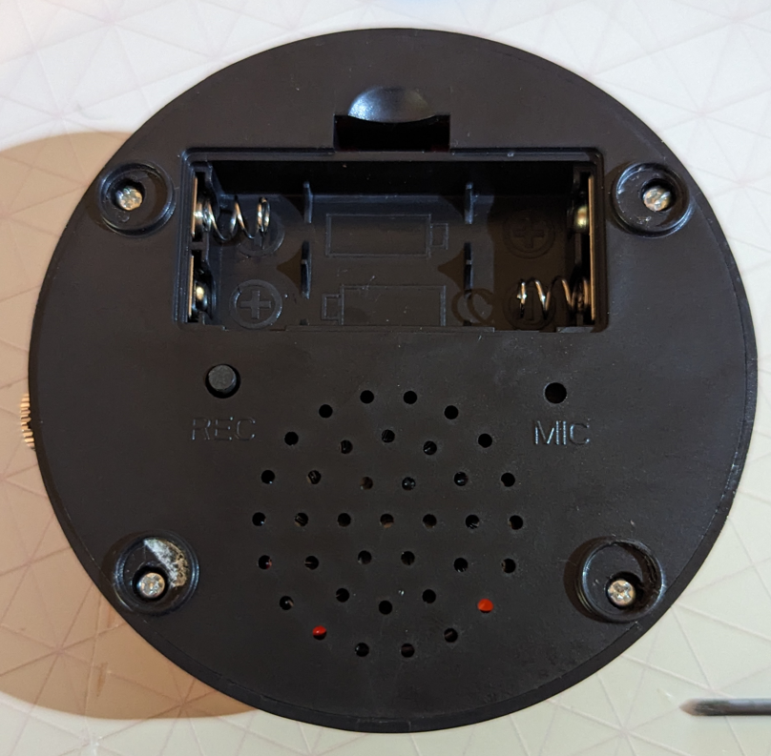

## Step 4 – Open up the casing

Remove the fours screws in the feet, and use the large button on the top to pop the base and top apart

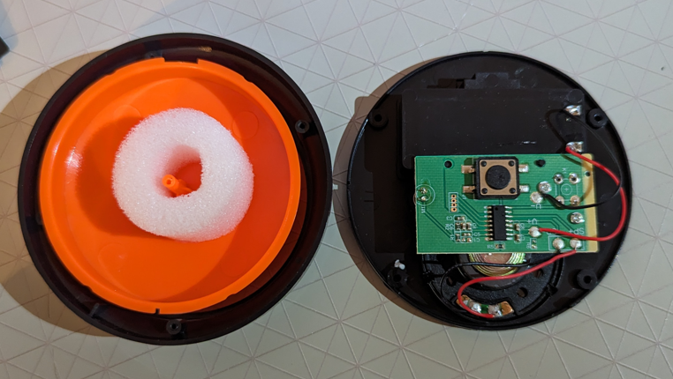

## Step 5 – Solder to the button

Take the two wires, and strip the insulation a centimeter from each side. Solder the wires to one side of the button, either side will work. Here, the wires have been soldered on the left side of the button in the image below, as indicated by the arrows.

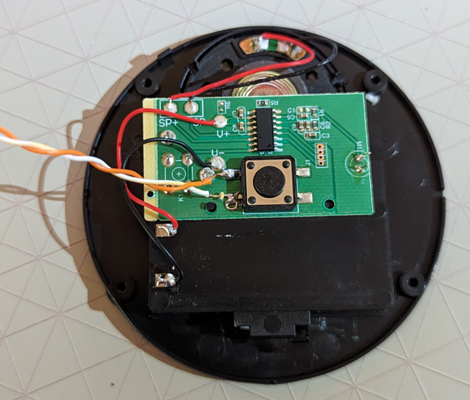

## Step 6 – Solder to the jack

Connect the other end of the two wires to the two tabs on the jack closest to the threaded port and solder them in place

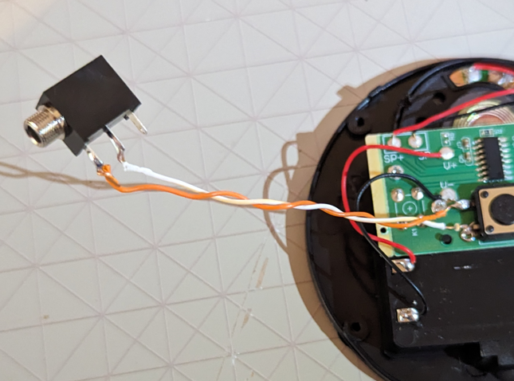

## Step 7 – Drill the hole for the jack

Flip the rim of the button upside down. Find the side opposite to the locating peg. In the picture below, the peg is on the left side, and the switch location will be on the right side. Take a ¼ inch drill bit and drill a hole roughly 3 mm (~1/8 in) from the bottom of the rim. If it is too low, the bottom won’t sit flush when the switch is reassembled, and if it is too high, the jack will want to seat at an angle and interfere with the bottom as well.

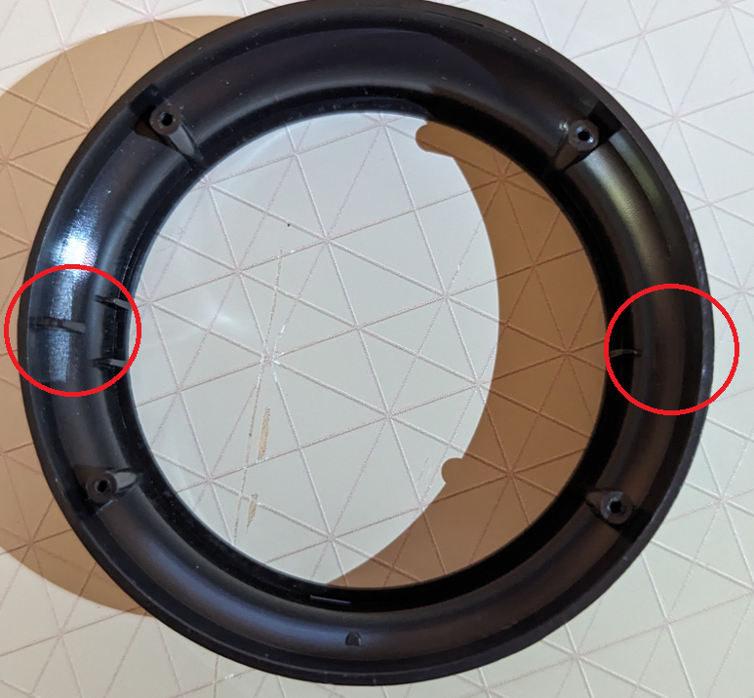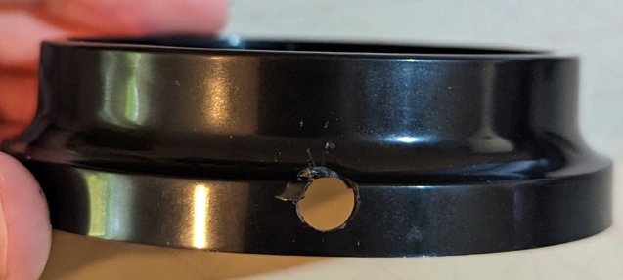

## Step 8 – Secure the jack

Put the jack through the hole, and secure it with the retaining ring.

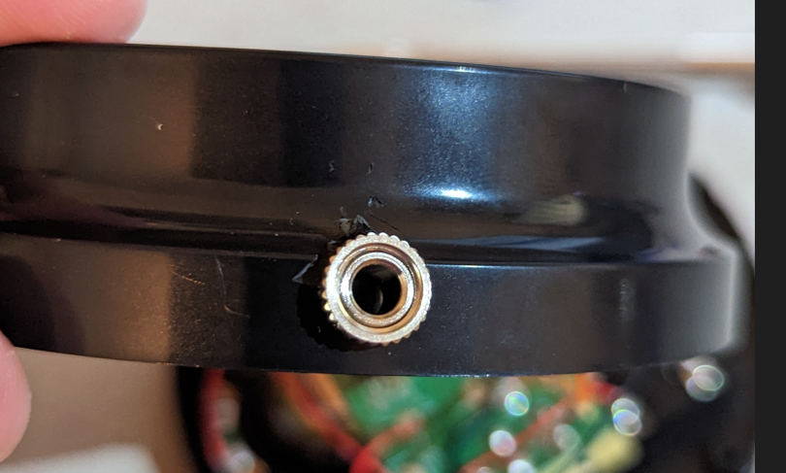

## Step 9 – Wire management

Tuck all wires out of the indicated area to prevent them from getting snagged on the jack during reassembly

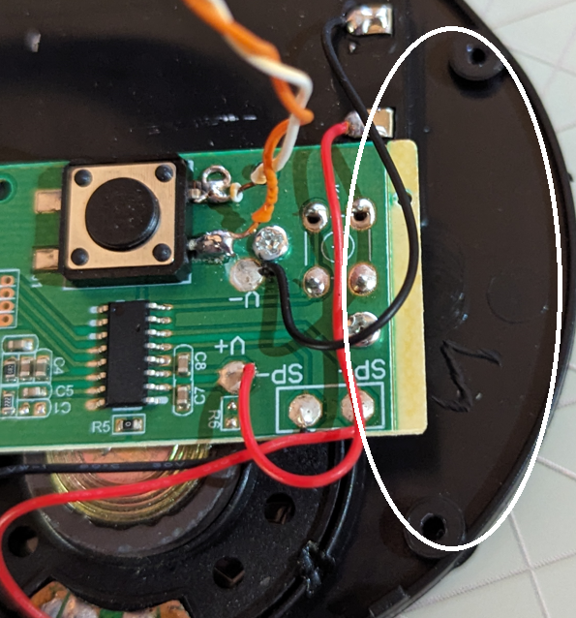

## Step 10 – Reassemble the cap

Place the button cap and foam back into the retaining ring

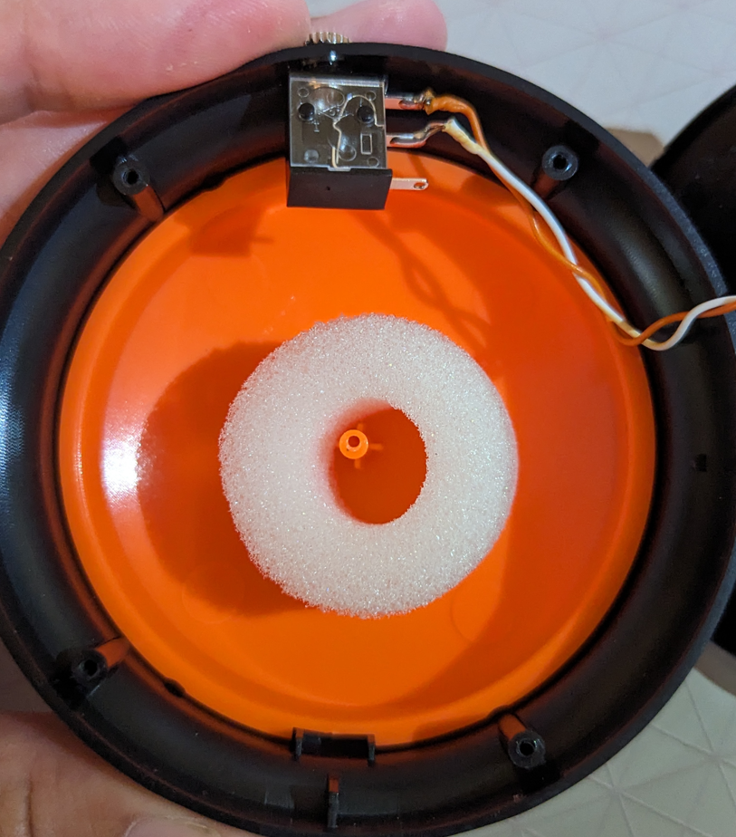

## Step 11 – Line up the halves

Line up the peg on the retaining ring with the slot on the base as shown in the image.

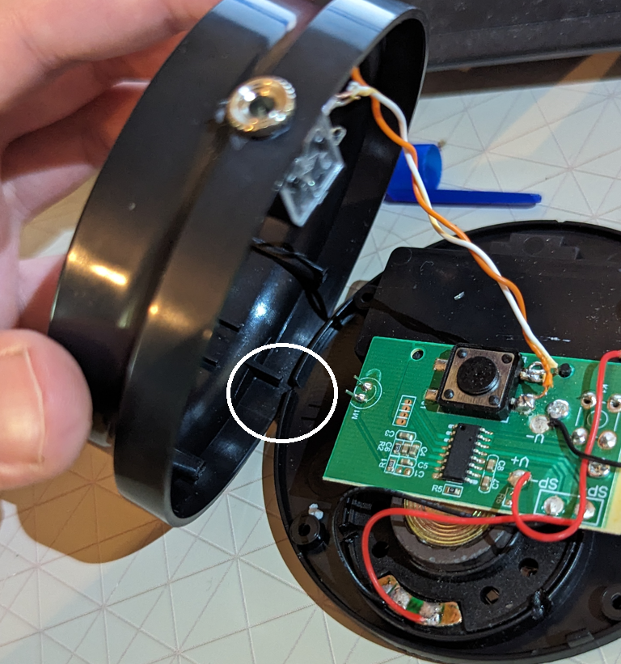

## Step 12 – Reattach the halves

Close the switch, and put the screws back in to hold it together

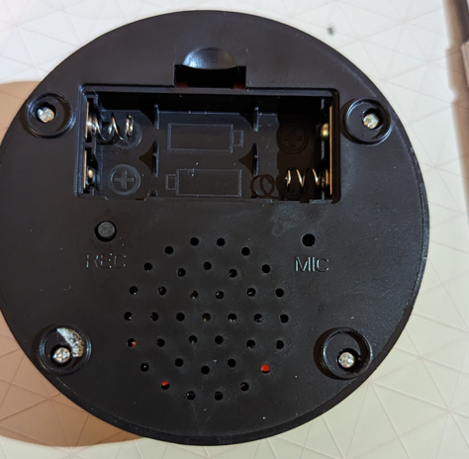

## Step 13 – Replace batteries and feet

Put the rubber covers back over the screws, and replace the batteries

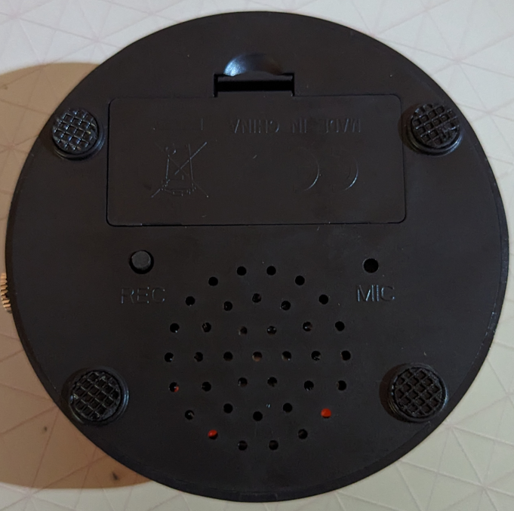

## Step 14 – Final Testing

Test the device to make sure it still works. Replace the batteries, and press and hold the REC button to record a message. The message can be played by pressing the button on top of the device, or by activating a switch attached to the new jack.

# Alternative Assembly

The jack and wire can be replaced with a female 3.5mm mono cable to make a pigtail style switch adapt. These steps replace steps 5-8 in the normal assembly guide. Follow Steps 1-4 from

## Step 5 – Strip the cable

Using wire strippers, remove the outer black cover on the wires. There will either be two or three wires in the cable. If there are two wires, strip the insulation a centimeter from the end, and use a soldering iron to pre-solder the exposed wires.

If there are three wires, strip a centimeter of insulation from the end of all three wires. Using a multimeter, determine which wire connects to the contact at the bottom of the jack. Trim this wire to the base of the black insulation (See the red wire in the attached photo.) Use a soldering iron and pre solder the remaining two wires.

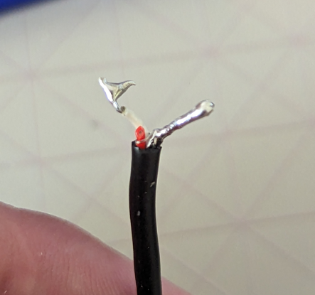

## Step 6 – Locate the hole

Flip the rim of the button upside down. Find the side opposite to the locating peg. In the picture below, the peg is on the left side, and the switch location will be on the right side. Take a 1/8 inch drill bit and drill a hole roughly 12 mm (~1/2 in) from the bottom of the rim. If it is too low, the bottom won’t sit flush when the switch is reassembled, and if it is too high, the jack will want to seat at an angle and interfere with the bottom as well.



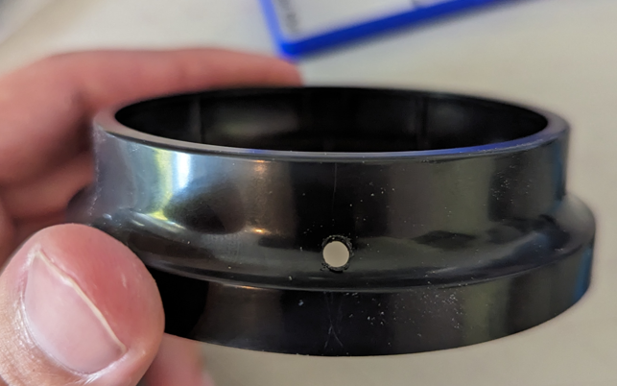

## Step 7 – Thread the cable

Thread the cable through the hole in the ring drilled in the previous step.

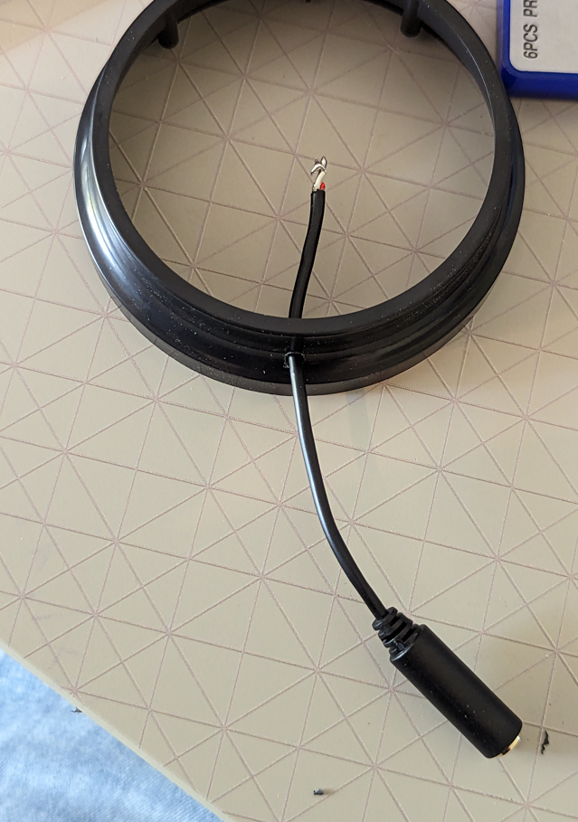

## Step 8 – Solder to the button

Solder the leads to the sides of the button. In the following image the leads have been soldered to the right side of the switch.

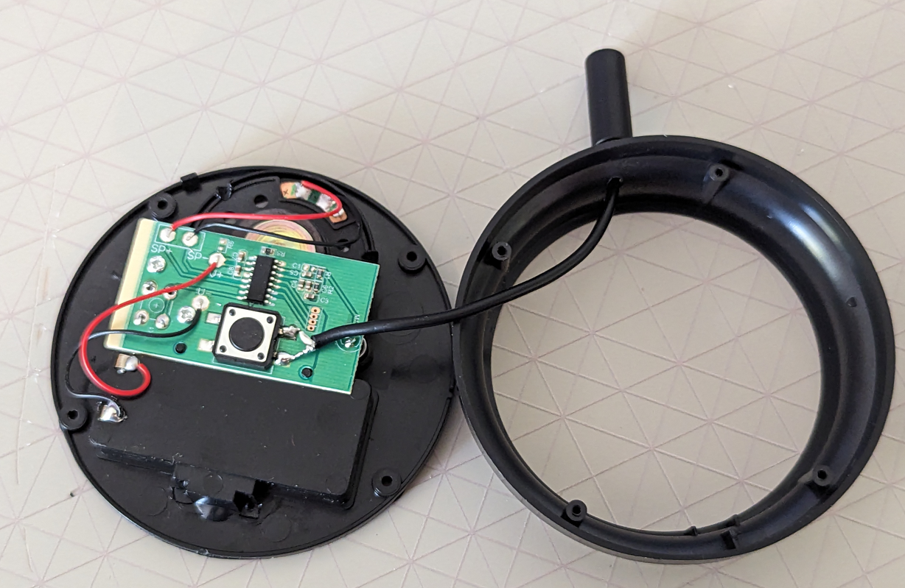

## Step 9 – Drill zip tie holes

Drill two 1/8th inch holes an eight of an inch apart near the side of the button where the wire comes out the side

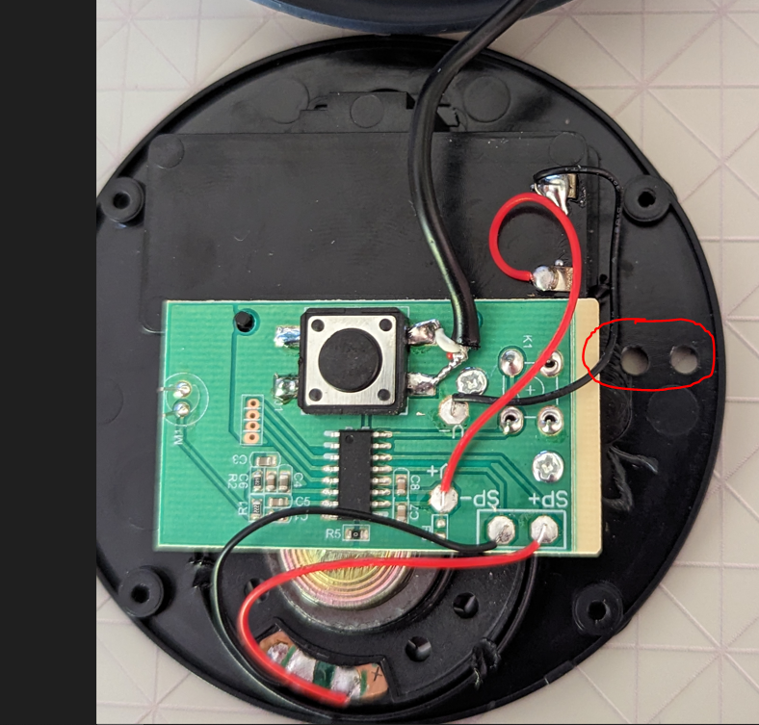

## Step 10 – Zip tie the cable

Loop a zip tie through the holes, and loosely attach it around the cable

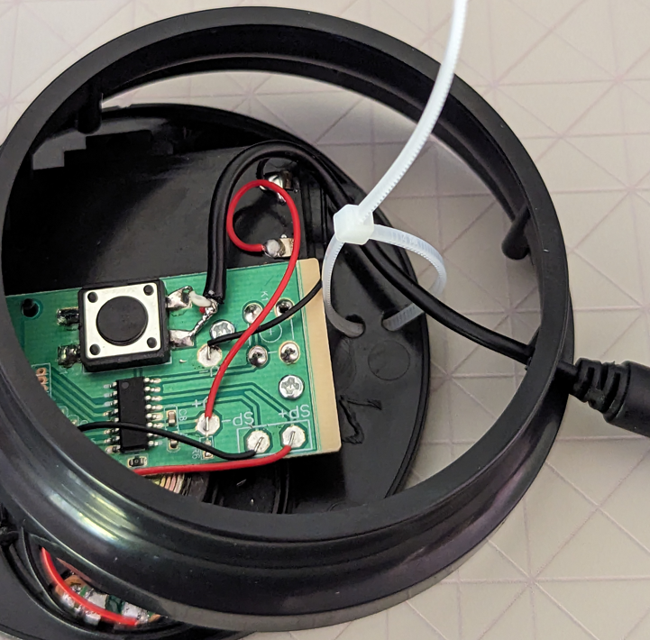

## Step 11 – Tighten the cable

Position the cable and tighten the zip tie to secure it in place. Trim the extra length.

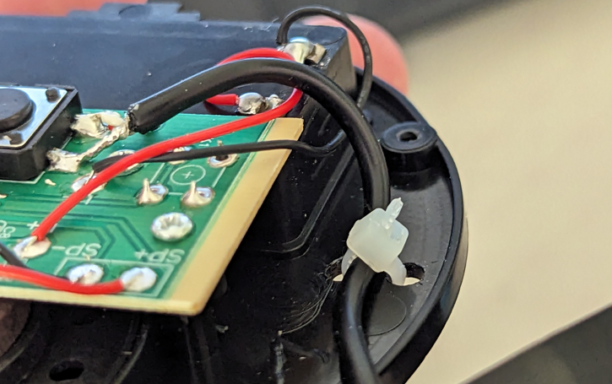

Follow Steps 10-14 from the previous section to finish reassembling and testing the button.

## Finished Assembly

